
Department of Computer Science and Engineering
Course Code & Name | CSA06 – Design and Analysis of Algorithms
Assessment | CO1 – Assessment Tool 1: IT Application-Based Problem Solving – Scalability Audit of an E-Commerce Platform
Course Outcome Assessed | Determine algorithm efficiency using asymptotic notations and mathematical techniques including Master Theorem and substitution method.
Duration | 3 Days
Mode | Individual
Student Reg. No. | 192572110(CSE AI)
Student Name | S. Venkata Anirudh

Problem Understanding and Design Goals
The university stores student records identified by unique Registration Numbers. The key operation is locating a requested Registration Number and retrieving the corresponding record. The system must remain practical as the database grows from 1,000 to 1,000,000 or more records. Because preprocessing such as sorting or constructing an index can be performed, its cost must be included in the total efficiency analysis.
Three meaningfully different strategies are investigated:
- A1 – Linear search on the existing unsorted records: iterative, no preprocessing, sequential design.
- A2 – Hash-table indexing: iterative lookup with Θ(n) expected preprocessing and Θ(1) expected lookup; chosen because it is fundamentally different from ordered searching.
- A3 – Binary search on a sorted Registration Number index: recursive divide-and-conquer lookup with Θ(n log n) preprocessing if sorting is required and Θ(log n) per search.
These three approaches cover a no-preprocessing baseline, a direct indexing strategy, and an ordered divide-and-conquer strategy. They also satisfy the requirement for at least one iterative and at least one recursive approach without counting iterative/recursive versions of the same algorithm as separate strategies.

Q1. Design the Algorithm

A1 – Iterative Linear Search
Design strategy: direct sequential search. The records remain in their existing order. The algorithm checks one Registration Number at a time until it finds the target or reaches the end.
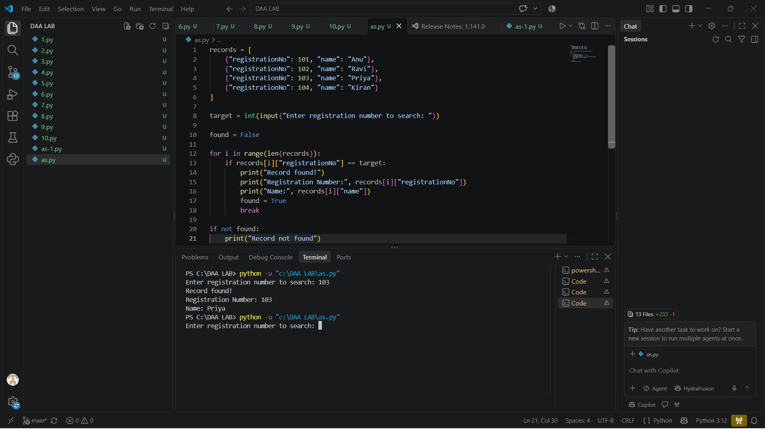
Preprocessing: none.
Pseudocode:
LINEAR-SEARCH(records, target)
FOR i ← 0 TO n − 1
IF records[i].registrationNo = target
RETURN records[i]
RETURN NOT FOUND
Reason for selection: it is the simplest baseline and is useful when the dataset is small, unsorted, or changed so frequently that preprocessing is undesirable.

A2 – Hash-Table Indexing
Design strategy: direct addressing through hashing. A hash table maps each unique Registration Number to its record. The table is built once and then queried directly.
Preprocessing: construct a hash table by inserting all n records. Expected preprocessing is Θ(n).
Pseudocode:
BUILD-HASH-INDEX(records)
CREATE empty hash table H
FOR each record r in records
H[r.registrationNo] ← r
RETURN H
HASH-SEARCH(H, target)
IF target is in H
RETURN H[target]
RETURN NOT FOUND
Reason for selection: it gives expected constant-time lookup and is especially attractive when many searches are performed against relatively stable data.

A3 – Recursive Binary Search on a Sorted Index
Design strategy: divide and conquer. First sort the records by Registration Number. During each search, compare the target with the middle Registration Number and recursively continue in only one half.
Preprocessing: sorting costs Θ(n log n) with a comparison-based sorting algorithm such as merge sort or an efficient library sort.

Pseudocode:
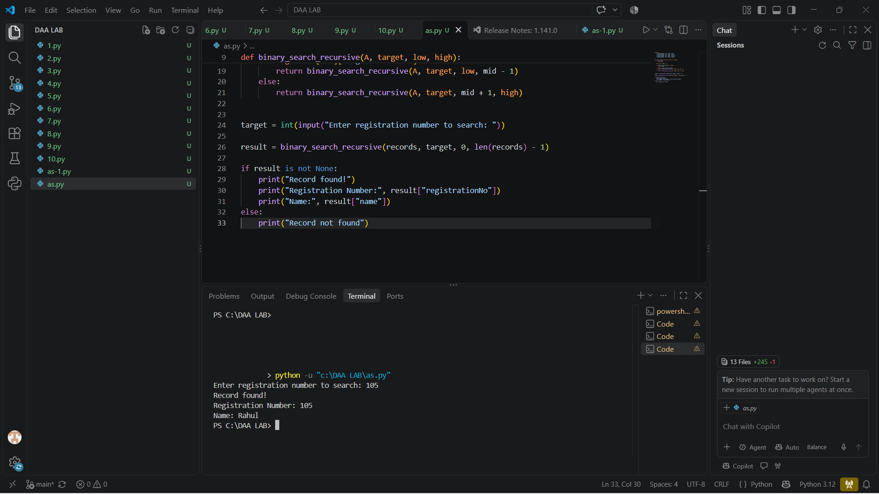
BINARY-SEARCH-RECURSIVE(A, target, low, high)
IF low > high
RETURN NOT FOUND
mid ← floor((low + high) / 2)
IF A[mid].registrationNo = target
RETURN A[mid]
IF target < A[mid].registrationNo
RETURN BINARY-SEARCH-RECURSIVE(A, target, low, mid − 1)
ELSE
RETURN BINARY-SEARCH-RECURSIVE(A, target, mid + 1, high)
Reason for selection: binary search has very low per-query cost and its recursive structure provides a clear recurrence f or analysis. It is a strong alternative when an ordered index is useful for other operations as well.

Q2. Identify the Basic Operation
Approach | Basic operation | Where it occurs | Growth with n
A1 Linear | Registration-number equality comparison | Inside the single FOR loop | 1 to n comparisons; worst case n
A2 Hash | Hash-table key lookup/equality check | At H[target] / membership test | Expected constant number of bucket/probe operations per query
A3 Binary | Comparison of target with middle key | At every recursive call | One comparison per level; approximately log₂n levels
The selected operations are appropriate because each is executed once per main unit of search work: a record examined for linear search, a table lookup for hashing, and a level of the divide-and-conquer search for binary search.

Q3. Derive the Time-Complexity Function Mathematically

A1 – Linear Search
Let n be the number of records. If the target is at position k (1-indexed), exactly k Registration Number comparisons are made. In the worst case, k = n.
C_linear,worst(n) = n
With no preprocessing:
T_linear,total(n) = n = Θ(n) (worst case)
Average successful search, assuming every position is equally likely:
C_avg,found = (1 + 2 + … + n)/n = (n + 1)/2
If a search succeeds with probability p and is absent with probability 1 − p:
E[C] = p(n + 1)/2 + (1 − p)n = n − p(n − 1)/2
Thus expected cost is still Θ(n) for any fixed p < 1 or p = 1.

A2 – Hash Table
Building the index inserts each of n records once. If one expected constant amount of work is associated with each insertion:
P_hash(n) = cn = Θ(n)
For a well-designed hash table with controlled load factor, the expected number of probes/lookups for one key is bounded by a constant:
S_hash,expected(n) = Θ(1)
For q search requests after the index has been built:
T_hash,total(n,q) = Θ(n) + Θ(q)
This distinction is important: preprocessing is linear in the database size, but the marginal cost of each additional search is expected constant time. The worst case of a badly behaved hash table can degrade to Θ(n) for a lookup, but this is not the expected case under normal hashing assumptions.

A3 – Recursive Binary Search
Sorting is required if the records are not already ordered. Comparison sorting costs:
P_binary(n) = Θ(n log n)
For a single binary search, one middle-element comparison is performed and the remaining problem contains approximately n/2 records:
S_binary(n) = S_binary(n/2) + c
After k levels, the subproblem size is n/2ᵏ. Stop when:
n/2ᵏ = 1 ⇒ k = log₂n
Therefore the search performs approximately log₂n comparisons, giving Θ(log n). Including preprocessing:
T_binary,total(n,q) = Θ(n log n) + Θ(q log n)
If the index is already maintained in sorted form by the database, the sorting cost need not be paid for every batch; only the update/index-maintenance cost is relevant.

Total Cost Comparison
Approach | Preprocessing | One search | q searches after preprocessing
Linear | Θ(1) | Θ(n) worst case | Θ(qn)
Hash index | Θ(n) expected | Θ(1) expected | Θ(n + q) expected
Sorted + binary | Θ(n log n) | Θ(log n) | Θ(n log n + q log n)

Q4. Best, Average and Worst-Case Behaviour

A1 – Linear Search
Best case: the requested student is the first record, so only one comparison is made: C_best = 1 = Θ(1). Average successful case: every position is equally likely, giving (n + 1)/2 comparisons. Worst case: the record is last or absent, requiring n comparisons. The differences occur because linear search has no information allowing it to eliminate multiple records at once.

A2 – Hash Search
Best/typical expected case: the hash function maps the target directly to an available slot, requiring a constant number of operations. Average expected case: Θ(1) lookup under a controlled load factor. Worst case: many keys collide into the same bucket, potentially requiring Θ(n) work. Good hashing, resizing, and an appropriate load factor make the worst case rare.

A3 – Recursive Binary Search
Best case: the target is exactly the middle entry, requiring one comparison. Average case: Θ(log n), because each comparison eliminates roughly half the remaining entries. Worst case: the target is absent or lies at the deepest leaf, requiring floor(log₂n) + 1 comparisons under the usual comparison convention. The logarithmic behaviour comes from halving the search space at every recursive call

Q5. Asymptotic Analysis
Approach | O upper bound | Ω lower bound | Θ tight bound | Meaning at very large n
Linear | O(n) | Ω(1) best / Ω(n) worst | Θ(n) worst | Search work grows directly with records
Hash index | O(1) expected lookup | Ω(1) expected | Θ(1) expected lookup | Database size has little effect on each lookup after indexing
Binary search | O(log n) | Ω(1) best / Ω(log n) worst | Θ(log n) worst | Doubling records adds only about one comparison
At 1,000 records, linear search can still be practical. At 1,000,000 records, a worst-case linear search can require one million comparisons per request. Binary search needs only about 20 comparisons because 2²⁰ = 1,048,576. A hash index has expected constant lookup cost. Therefore the growth difference becomes decisive at very large scale.

Q6. Formulate the Recurrence Relation
The recursive approach is A3, binary search. The original input size is n records in the current search interval. At each recursive call, exactly one middle record is inspected and one half is discarded. Therefore the next subproblem contains approximately n/2 records. There is one recursive call and constant work c outside it for computing the midpoint and comparing the key.

T(n) = T(n/2) + c, for n > 1
Base case: when the interval contains one record, or when low > high, the algorithm performs constant work:
T(1) = c₀
Thus the recurrence follows directly from the algorithm: one subproblem of half the size plus constant non-recursive work.

Q7. Solve the Recurrence Relation
Substitution/iteration is appropriate because each recursive call halves the input and adds a constant amount of work.
T(n) = T(n/2) + c
= [T(n/4) + c] + c = T(n/4) + 2c
= T(n/8) + 3c
= …
= T(n/2ᵏ) + kc
The recursion stops when n/2ᵏ = 1:
2ᵏ = n ⇒ k = log₂n
T(n) = T(1) + c log₂n
T(n) = c₀ + c log₂n = Θ(log n)
Interpretation: even when the database grows by a factor of 1,000, the number of binary-search levels grows only by an additive constant of log₂(1,000) ≈ 10 levels.

Q8. Implement and Test the Algorithms
The experiments use the same Registration Numbers 1, 2, …, n for all approaches. The linear algorithm searches the original list; binary search uses a sorted copy; hashing uses a dictionary-style index. A present target near the middle is used for the main timing comparison, and correctness is checked for every implementation. Preprocessing is timed separately so that it is not hidden.

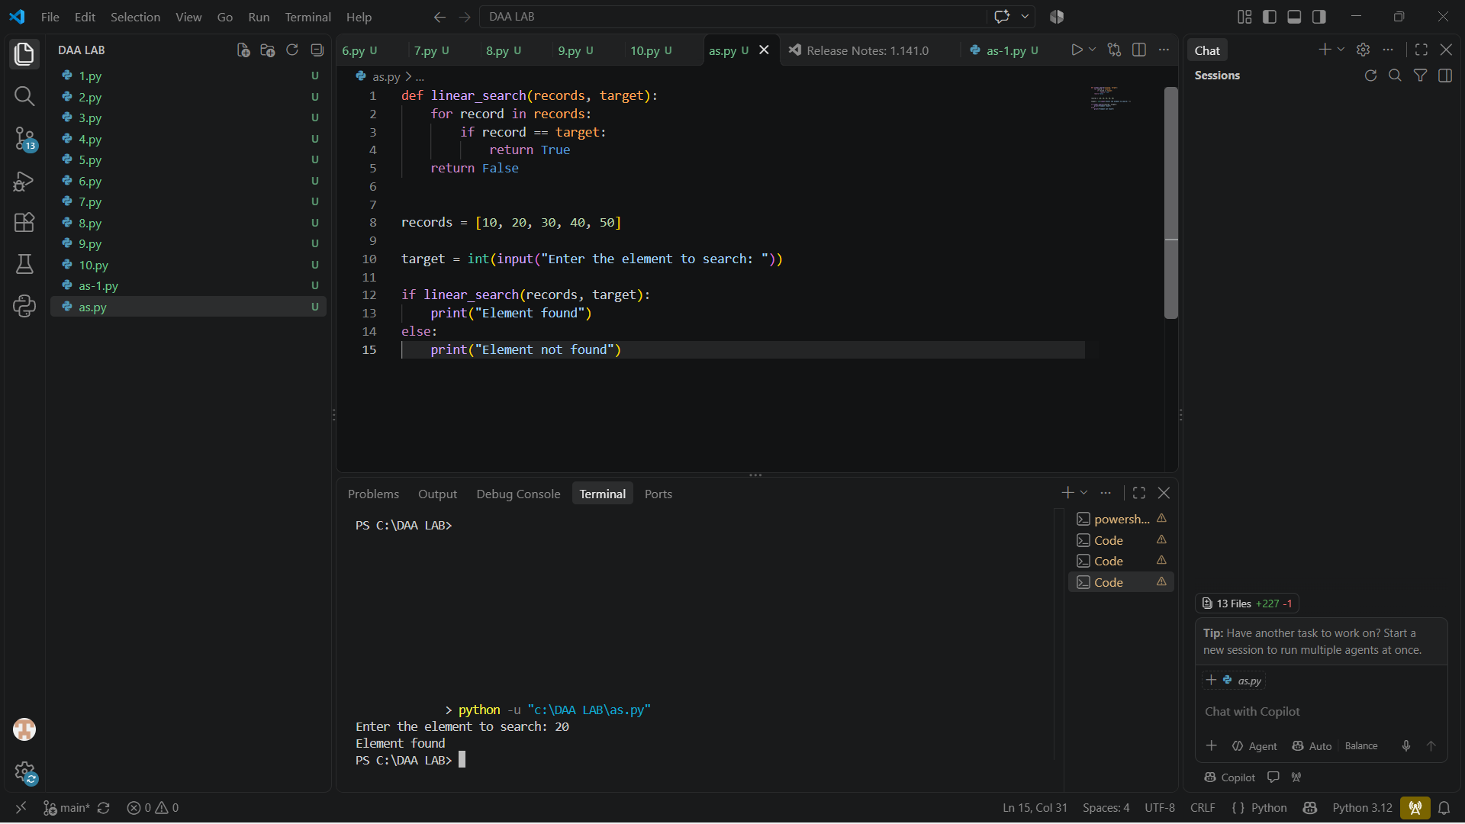
Implementation 1 – Linear Search (Python)
def linear_search(records, target):
for record in records:
if record == target:
return True
return False

Implementation 2 – Hash Index (Python)
def build_hash_index(records):
return {record: record for record in records}
def hash_search(index, target):
return target in index

Implementation 3 – Recursive Binary Search (Python)
def binary_search_recursive(A, target, low, high):
if low > high:
return False
mid = (low + high) // 2
if A[mid] == target:
return True
if target < A[mid]:
return binary_search_recursive(A, target, low, mid - 1)
return binary_search_recursive(A, target, mid + 1, high)
For experimental comparison, an iterative binary-search implementation was also timed as an implementation check; it is not counted as a fourth algorithm because it is the same underlying binary-search strategy.

Experimental Results
n | Linear time (s) | Linear comps | Sort time (s) | Binary iter (s) | Binary comps | Binary rec (s) | Rec comps | Hash build (s) | Hash lookup (s)
1,000 | 0.000020 | 500 | 0.000009 | 0.000003 | 1 | 0.000002 | 1 | 0.000033 | 0.000001
10,000 | 0.000144 | 5,000 | 0.000086 | 0.000001 | 1 | 0.000001 | 1 | 0.000448 | 0.000001
100,000 | 0.001846 | 50,000 | 0.000739 | 0.000002 | 1 | 0.000001 | 1 | 0.004305 | 0.000001
1,000,000 | 0.015674 | 500,000 | 0.008801 | 0.000008 | 1 | 0.000004 | 1 | 0.042132 | 0.000002
Note: wall-clock timings are machine- and language-dependent and should be treated as experimental evidence rather than universal constants. The operation counts and asymptotic conclusions are the stronger theoretical evidence.
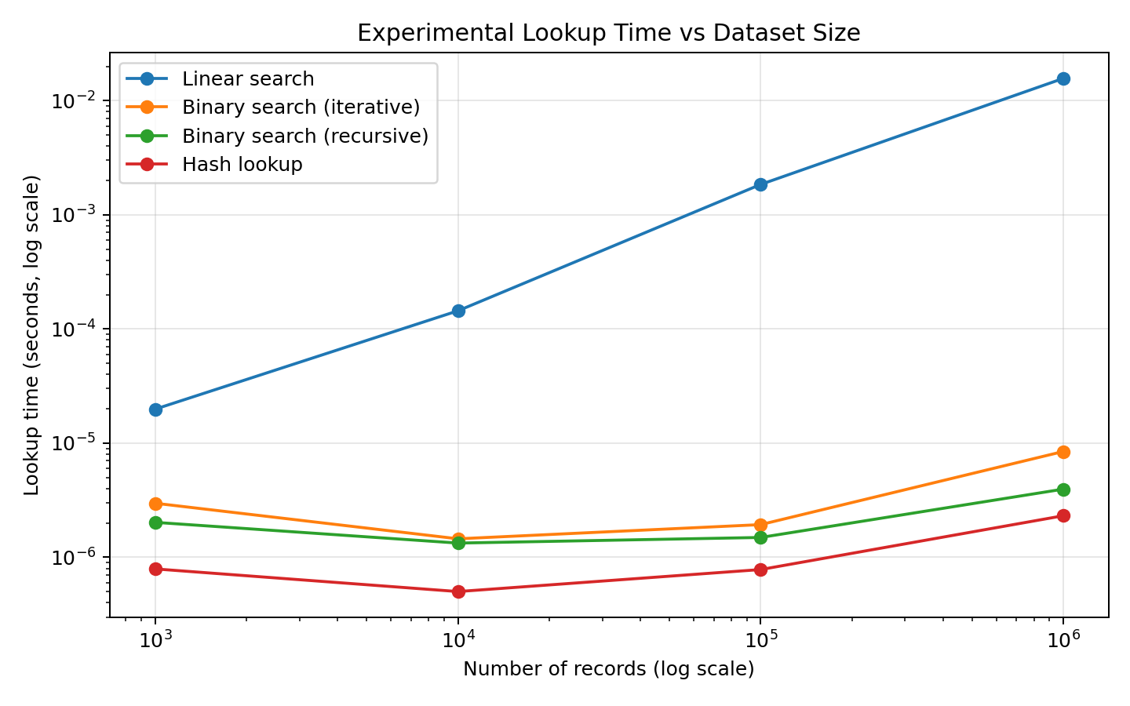
Figure 1. Experimental lookup-time growth. Logarithmic axes make the very different growth rates visible.
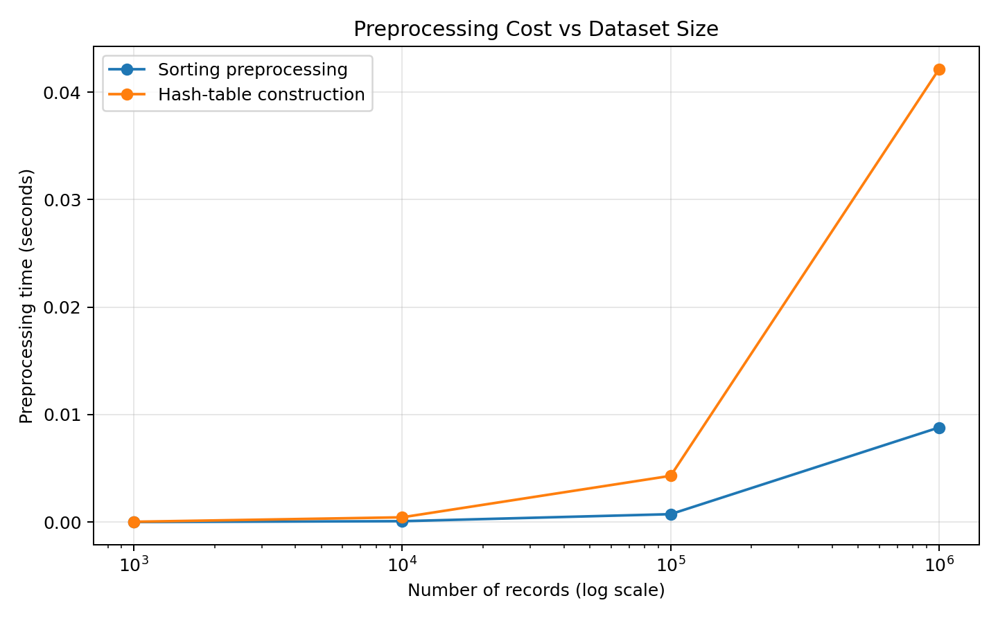
Figure 2. Preprocessing costs for sorting and hash-index construction.

Q9. Record Experimental Performance
The experiment records execution time, comparison count for comparison-based searches, and preprocessing time. Linear-search comparison counts grow approximately proportionally to n. Binary-search comparison counts stay near log₂n. Hash lookup requires a constant expected number of key operations after its linear construction phase.
For n = 1,000,000, binary search requires only about 20 comparisons because 2²⁰ = 1,048,576. Linear search with a middle-position target requires roughly 500,000 comparisons in this particular experiment, and an unsuccessful search would require the full 1,000,000 comparisons.

Q10. Compare Theory with Experimental Behaviour
The experimental behaviour agrees with the theoretical analysis. Linear-search time increases substantially as n grows, while binary-search lookup time remains nearly flat on the plotted logarithmic scale. Hash lookup is also nearly flat after its preprocessing stage. The comparison counts are especially strong validation because they are directly tied to the mathematical models.
- Linear search: observed work grows approximately linearly because each additional record can create another comparison.
- Binary search: observed comparison counts increase only logarithmically; the jump from 100,000 to 1,000,000 records adds only a few comparisons.
- Hash search: expected lookup remains constant-time, but construction grows linearly with n.
- Measured times do not exactly equal theoretical functions because Python interpreter overhead, memory allocation, cache behaviour, dictionary implementation, timer resolution, and operating-system activity affect wall-clock results.
- Sorting and hash construction are one-time or infrequent costs in a static-data workload, so their amortized cost per search becomes small when many searches are performed.

Q11. Recommend and Defend the Final Design
Recommended primary design: A2 – hash-table indexing, provided that the university's main requirement is exact Registration Number lookup and the database is updated relatively infrequently.
Reasoning: the hash index costs Θ(n) expected preprocessing but provides Θ(1) expected lookup. With many searches and few updates, the preprocessing cost is amortized over a large number of queries. It is therefore particularly well matched to a stable academic database.
Secondary recommendation: maintain a sorted index as well if the system also needs ordered reports, range queries, prefix navigation, or deterministic logarithmic worst-case lookup. Binary search gives Θ(log n) lookup and has excellent scalability, at the expense of Θ(n log n) sorting if the data is not already sorted.
Linear search should be retained only as a simple baseline or for very small/rarely searched datasets. It does not remain attractive at one million records when query volume is high.
Trade-off summary: hashing provides the best expected exact-key lookup, binary search provides predictable logarithmic lookup and ordered access, and linear search has zero preprocessing but poor scaling.

SECTION B – DAY-4 DESIGN CHALLENGE

Q12. Re-evaluate and Adapt the Design
Changed requirement: 50,000 search requests per hour on a database containing 1,000,000 records, while new records are added only once per day.
Decision: MODIFY the design into a persistent hash-based Registration Number index, with optional sorted indexing for reporting. The core exact-key retrieval strategy becomes hash indexing because the new workload is query-heavy and update-light.

(a) Impact Analysis
The original problem described a growing database and frequent retrieval but did not specify an exact query rate. The new requirement makes the query frequency explicit: 50,000 searches/hour.
50,000 / 60 ≈ 833.3 searches/minute
50,000 / 3,600 ≈ 13.89 searches/second
The database has 1,000,000 records but receives only one batch of new records per day. This changes the cost trade-off: preprocessing an index once and reusing it for many searches is now highly attractive. A one-time daily update is inexpensive compared with repeatedly scanning one million records.

(b) Evaluation of the Original Design
If the original design were linear search, the worst case is 1,000,000 comparisons per request. For 50,000 requests/hour:
50,000 × 1,000,000 = 50,000,000,000 comparisons/hour
That is approximately 50 billion comparisons per hour, or about 13.89 million comparisons per second. Even if the average successful position were the middle of the list, the workload would still be about 25 billion comparisons per hour.
Binary search is much better:
50,000 × (floor(log₂1,000,000) + 1) ≈ 50,000 × 20 = 1,000,000 comparisons/hour
Hash indexing is even better in expected key-operation count: approximately 50,000 constant-time lookups per hour after the index is built.
Therefore the original no-preprocessing linear strategy is no longer acceptable. The preprocessing cost of hashing or sorting is clearly justified because the index is reused across tens of thousands of queries.

(c) Adaptation / Redesign
Revised strategy: build the hash index once when the daily update arrives, then serve all Registration Number requests from that index during the day.
Daily index construction = Θ(n) expected
50,000 lookups/day-hour = Θ(50,000) expected for one hour
For q searches: total = Θ(n + q) expected
If 50,000 requests occur every hour for 24 hours, then:
q_day = 50,000 × 24 = 1,200,000 searches/day
Total daily expected work = Θ(n + 1,200,000) = Θ(2,200,000) for n = 1,000,000
This is vastly better than 1.2 trillion linear-search comparisons per day.
1,200,000 × 1,000,000 = 1.2 × 10¹² comparisons/day
Because updates occur only once per day, the index can be rebuilt or incrementally updated during the daily maintenance window. The design therefore changes from 'search the raw records' to 'maintain an index and search the index.'

(d) Evidence-Based Defence
The decision follows from four pieces of evidence. First, n = 1,000,000 makes Θ(n) per-request scanning expensive. Second, 50,000 searches/hour means preprocessing can be amortized over a large query volume. Third, one daily update means the index does not need to be rebuilt after every request. Fourth, experiments show nearly constant lookup time for the hash index and logarithmic comparison growth for binary search.
Final decision: MODIFY/REDESIGN the original approach to use a persistent hash index for exact Registration Number retrieval. Keep or add a sorted index when ordered queries are also required. This solution remains practical as the student population grows, provided memory capacity, hash-table load factor, and daily update procedures are properly managed.

Final Design Decision at a Glance
Criterion | Linear | Hash index | Sorted + binary
Preprocessing | None | Θ(n) expected | Θ(n log n) if sorting required
Expected exact lookup | Θ(n) | Θ(1) | Θ(log n)
Worst-case lookup | Θ(n) | Θ(n) under severe collisions | Θ(log n)
50,000 searches/hour | Poor at n=10⁶ | Excellent | Excellent
Daily update frequency | No index maintenance | Very suitable | Suitable; update index carefully
Ordered/range access | Poor | Not naturally ordered | Excellent
Final role | Baseline/small data | Primary exact-key design | Secondary/ordered-access design
Overall conclusion: for the changed Day-4 workload, the university should maintain a hash-based Registration Number index as the primary retrieval mechanism. Binary search remains an excellent complementary strategy when ordered access or predictable logarithmic worst-case lookup is important.

Appendix A – Reproducible Experimental Code
The following compact Python program implements the three investigated strategies and can be extended for additional datasets or target distributions.
import time

def linear_search(A, target):
for x in A:
if x == target:
return True
return False

def build_hash_index(A):
return {x: x for x in A}

def hash_search(H, target):
return target in H

def binary_search_recursive(A, target, low, high):
if low > high:
return False
mid = (low + high) // 2
if A[mid] == target:
return True
if target < A[mid]:
return binary_search_recursive(A, target, low, mid - 1)
return binary_search_recursive(A, target, mid + 1, high)

sizes = [1000, 10000, 100000, 1000000]

for n in sizes:
A = list(range(1, n + 1))
target = n // 2

t0 = time.perf_counter()
print(linear_search(A, target))
print("linear:", time.perf_counter() - t0)

t0 = time.perf_counter()
H = build_hash_index(A)
build = time.perf_counter() - t0
t1 = time.perf_counter()
print(hash_search(H, target))
lookup = time.perf_counter() - t1
print("hash build:", build, "lookup:", lookup)

t0 = time.perf_counter()
A.sort()
sort = time.perf_counter() - t0
t1 = time.perf_counter()
print(binary_search_recursive(A, target, 0, n - 1))
print("sort:", sort, "binary:", time.perf_counter()0 - t1)

OUTPUT:

